Viral Cell Therapies Fighting Cancer
Posted by Richard Tsai on Mar 24, 2015 1:46:05 PM
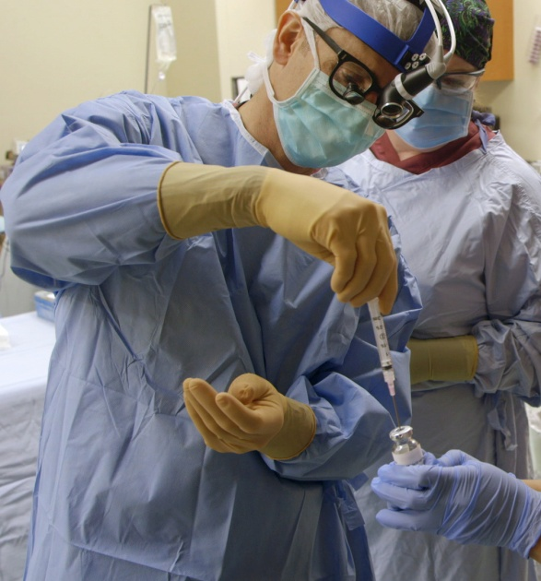
Emily Whitehead was diagnosed with acute lymophoblastic leukemia (ALL) in 2010. After two years of unsuccessful intensive chemotherapy, she was running out of treatment options and time. When the outlook was at its bleakest, she found out that she qualified for CTL019, a highly experimental phase I clinical trial where virus-modified T cells are administered to fight against the cancer. Following her enrollment and receiving this treatment, Emily had severe symptoms and became critically ill with cytokine release syndrome, a type of systemic inflammatory response to treatment. After spending several weeks in the pediatric intensive care unit (PICU) at CHOP her doctors conducted a bone marrow test where the results showed no evidence of the disease whatsoever. Her successful reaction to this cutting edge treatment has led people to believe that viral cell therapies are not only a treatment, but a potential cure for leukemia cancer. Talk about a game changer.
HBO's VICE, an Emmy-winning documentary series, is a dynamic and ground breaking news program that discusses controversial topics and pushes the envelope. The season three premier was preceded by a special report called Killing Cancer which highlighted stories like Emily's and discussed how common viruses like small pox, measles, and even HIV are being used to battle and possibly cure cancer.
Key Players
In addition to featuring the story of Emily's journey through treatment at the University of Pennsylvania Abramson Cancer Center, the episode also showed other experts from across the country, as well as Canada, and gave insight into their research and clinical trials.
- At the Mayo Clinic, the measles virus was used to fight multiple Myeloma, a cancer of plasma cells in the bone marrow that causes skeletal or soft tissue tumors.
- Dr. John Bell discussed how oncolytic virus clinical trials are being conducted at the Ottawa Hospital Research Institute. In 2010, he first discovered that an injectable form of the smallpox virus could be manipulated into killing cancer cells without damaging healthy tissue.
- At MD Anderson Cancer Center in Houston, the virus for the common cold (also known as the adenovirus) was surgically injected into the patient's brain tumor to combat the cancer.
How does this treatment work?
Traditional cancer treatments include chemotherapy, surgical therapy, and radiation therapy and have been tremendously successful for many patients with cancer. Unfortunately, a side effect of these treatments is they oftentimes negatively impact other parts of the body by destroying normal tissue. By genetically reprogramming T cells to act like antibody based B cells, researchers at UPenn's Ambramson Cancer Center hoped the patient's immune system would target their cancer specifically, without all of the collateral damage.
The first step of the treatment is to collect the patient's immune cells so that they can be genetically modified and therefore recognize and kill their cancer. When the cells are collected, they're then brought to a cell production facility where they undergo genetic modification and are grown in a laboratory. After a few weeks the cells are ready for infusion into the patient and shortly thereafter, the cells begin growing in the body. This typically leads to a reaction known as asiteokin release syndrome which causes severe flu like symptoms such as fever, intense nausea, and inability to eat. If their symptoms are severe enough, patients will be admitted to the hospital for close monitoring. After 3-4 weeks of navigating through the symptoms, tests will be run to detect any remaining cancer and oftentimes, this treatment is successful and causes pounds of cancerous tumor to dissipate.
Long term effects
Based on these trials, researchers have found that the genetically modified T cells continue to survive in the patient's body and remain active after treatment. The CD19 molecule is now being used with other forms of leukemia and UPenn has treated 32 patients in two different clinical trials. Roughly half of the patients have had very major clinical responses, and half of those patients had complete remission and disappearance of the leukemia from their bone marrow, blood, enlarged lymph nodes, spleen, and liver. The overall finding is that researchers can reprogram the immune system and make it more potent than it was made by nature.
Industry impact
The life sciences community is collectively searching for new ways to treat and cure diseases because there is a patient waiting. We continue to read more and more about developments in personalized medicine, the progress of companion diagnostics, and innovative cell therapy solutions. As we explore and test the limits of science, we must also increase our knowledge of ways to facilitate the accessibility of these therapies through bioproduction/scale-up manufacturing and ultra cold chain logistics. Companies developing these revolutionary biopharmaceutical products frequently fail to address cold chain distribution until their product is nearing clinical trials. However, the complexity of maintaining cold chain, combined with ever more stringent regulatory requirements, creates a minefield of challenges in moving a therapy from the manufacturer’s door to the patient bedside. Companies that wait until their product is ready to enter clinical trials before considering packaging and cold chain distribution may inadvertently limit their product’s commercial viability.

